PALLADIUM STANDARD SETTING 2025
BACK TRUSS: 1 x Screen 6x6
6 x Maverick MK2: 3.001, 3.025, 3.049, 3.073, 3.097, 3.121
4 x Martin Rush MH3: 3.145, 3.164, 3.183, 3.202
MID TRUSS: 6 x Maverick MK2: 2.001, 2.025, 2.049, 2.073, 2.097, 2.121
4 x Martin Rush MH3: 2.355, 2.374, 2.393, 2.412
6 x B-EYE K25: 2.145, 2.180, 2.215, 2.250, 2.285, 2.320
2 x Atomic 3000: 2.505, 2.509
FRONT TRUS:7xMaverick Storm2:1.081, 1.129, 1.177, 1.225, 1.273, 1.321,1.369
4 x NICK NRG 1201: 1.001, 1.021, 1.041, 1.061
6 x PC 1000: 2.464, 2.465, 2.466, 2.469, 2.470, 2.471
4 x ETC 575 Profile: 2.467, 2.468, 2.484, 2.485
4 x Blinders: 2.463, 2.472, 2.483, 2.486
STAGE: Hazer MDG Atme + Fun: 1.500
6 x Martin Rush MH1: 4.289, 4.306, 4.323, 4.340, 4.357, 4.374 (optional)
6 x B-EYE K20: 6.001, 6.036, 6.071, 6.106, 6.141, 6.176 (optional)
2x NICK NRG 1201(crosslight back): 3.241, 3.301
2 x NICK NRG 1201(crosslight middle): 3.261, 3.281
2 x NICK NRG 1201 (crosslight front): 3.221, 3.321
4 x PAR 64 (crosslight front): 2.473, 2.474, 2.478, 2.480
6 x reserve dimmers: 2.487, 2.488, 2.489, 2.490, 2.491, 2.492
HOUSE light: 8.001, 8.002, 8.003
BALCONY: 6 x Maverick Storm 2: 4.001, 4.049, 4.097, 4.145, 4.193, 4.241
6 x PC 2000: 6 x PC 2000: 4.499, 4.500, 4.501, 4.502, 4.503, 4.504
MIXER: 1 x GRAND MA 3 LIGHT
LED Display P2,9; 35 m2, arc-lock design cabinet, indoor rental application
Maverick MK2: 24 ch
B-EYE K 20: Shapes 35 ch
Maverick Storm 2 49 ch
Martin Rush MH3: 00 19 ch
Martin Rush MH1: 00 17 ch
NICK NRG 1201: Macro Standard 20 ch
Gate IP : 2:132:128:49
Stage dimensions : Stage high – 91,3 m2
11 m width, 8,3 m depth, 1,75 height, 5,25 m from the base of the stage to the ceiling
Low Stage – 66 m2
11 m width, 6 m depth, 1 m height, 6 m from the base of the stage to the ceiling.

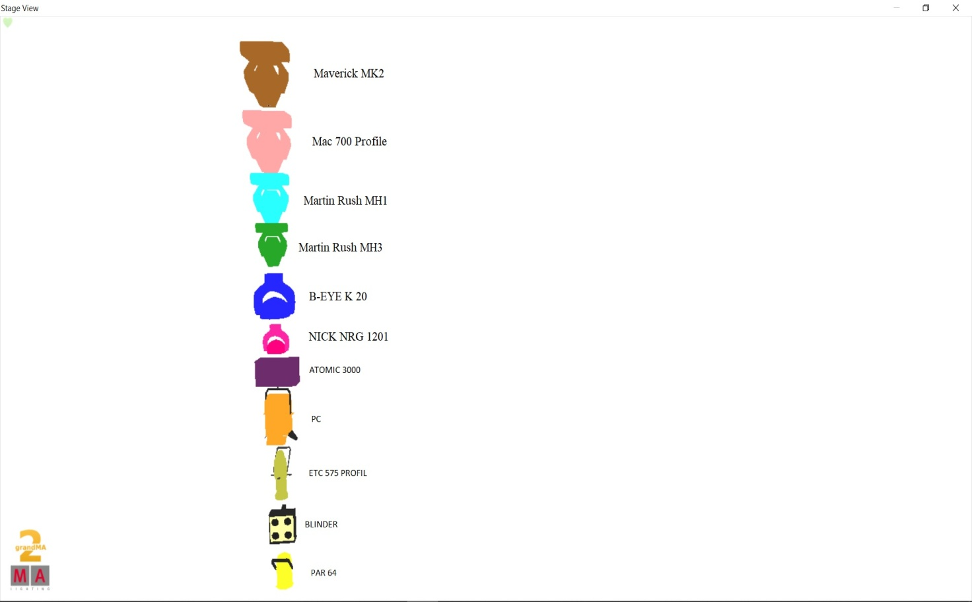
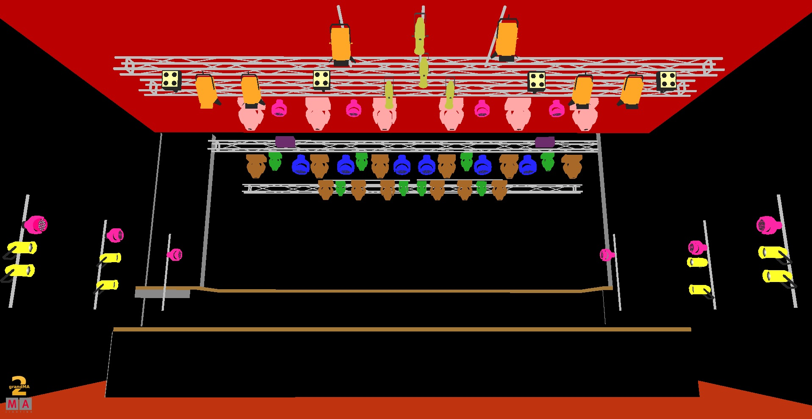

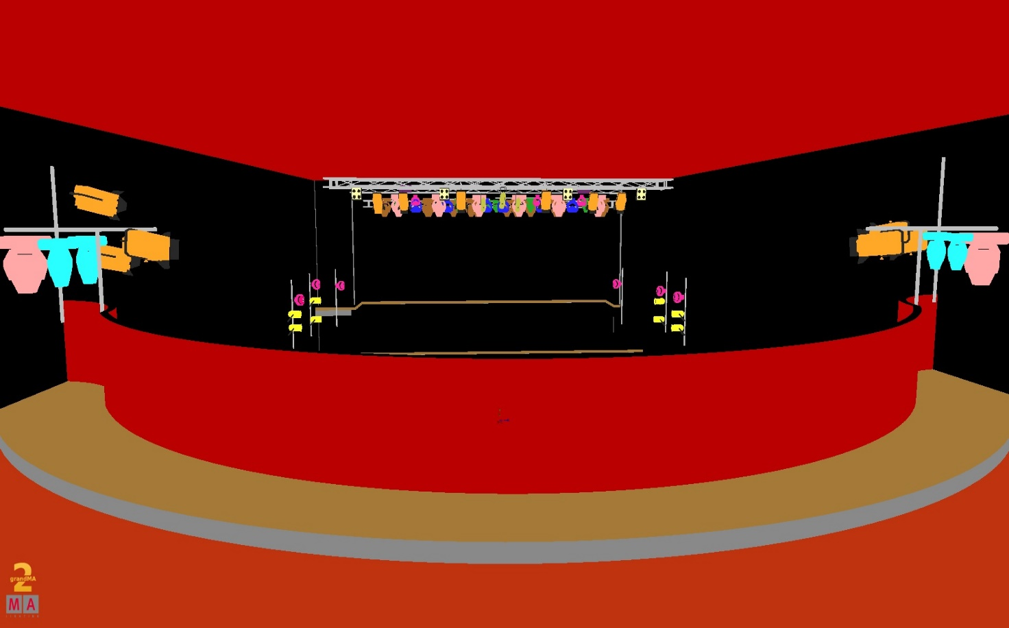

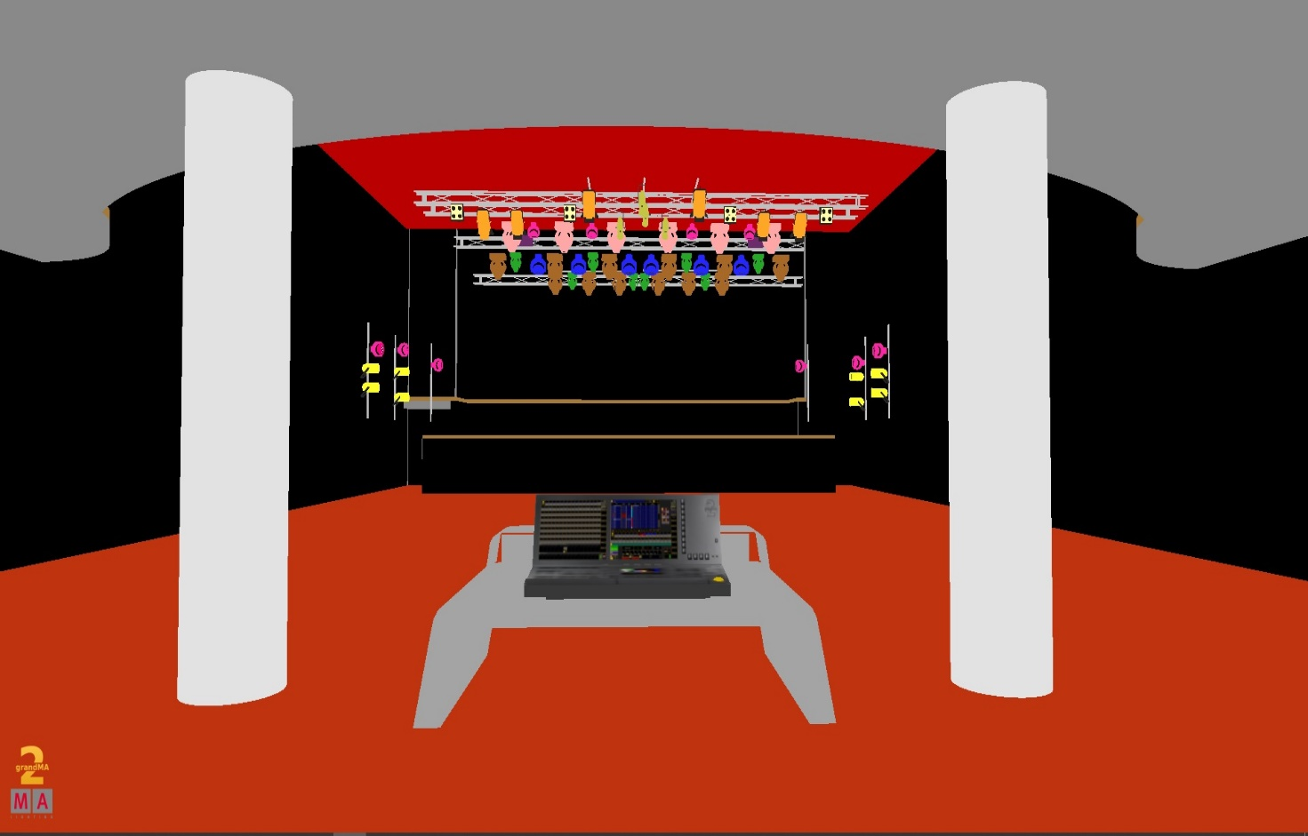

MK2
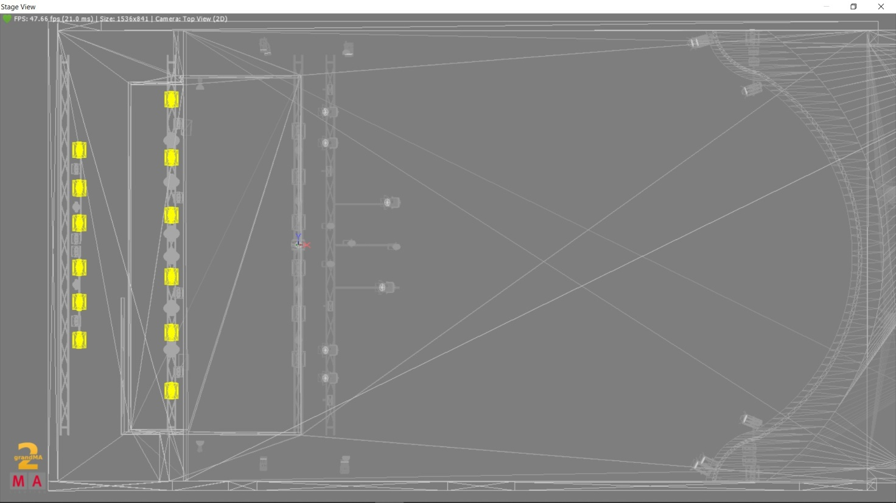

K20
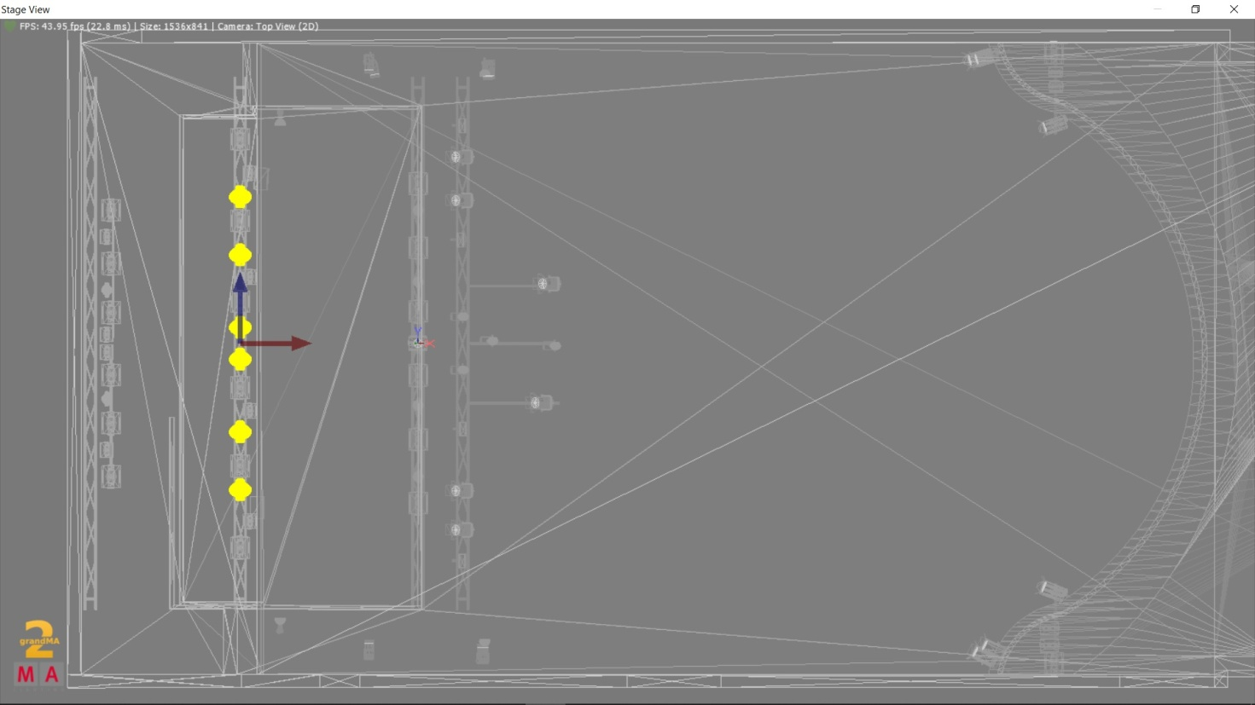

MH3
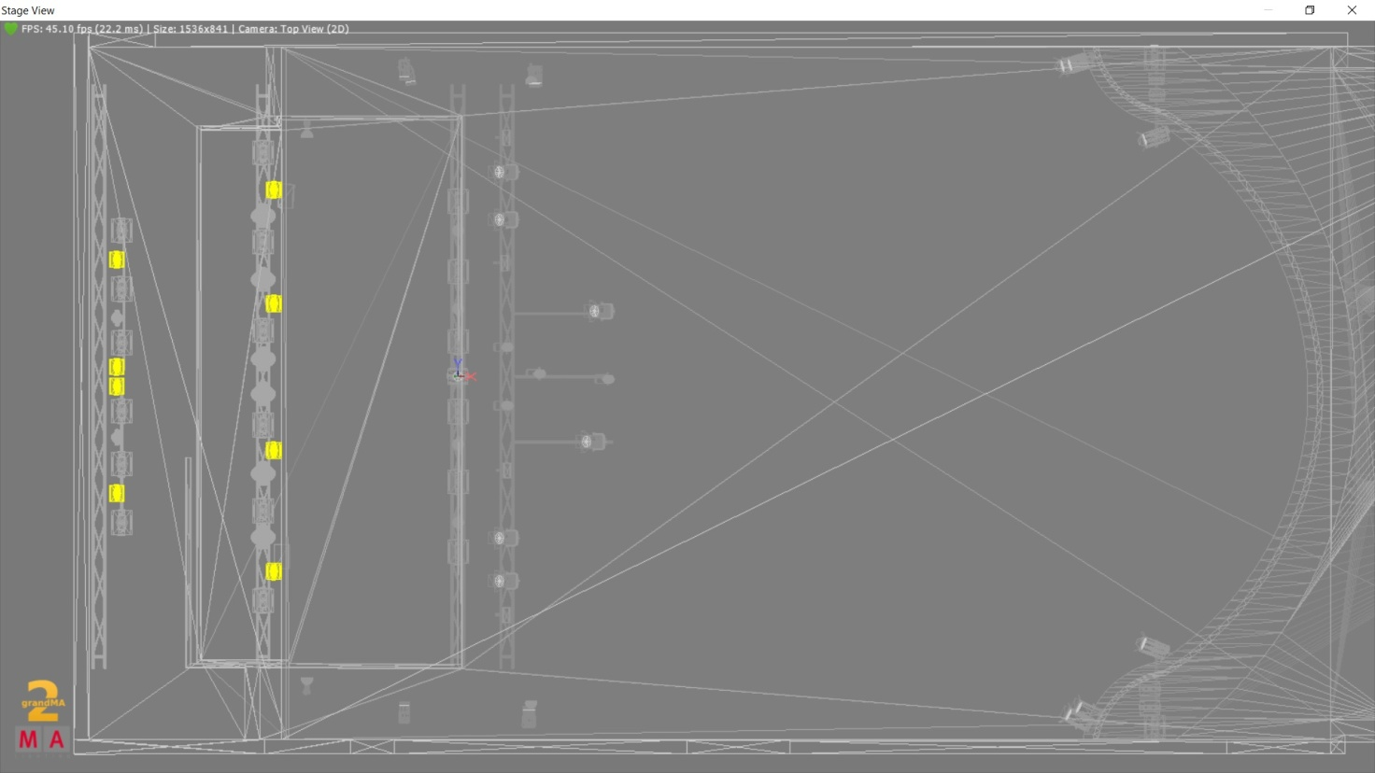

MH1
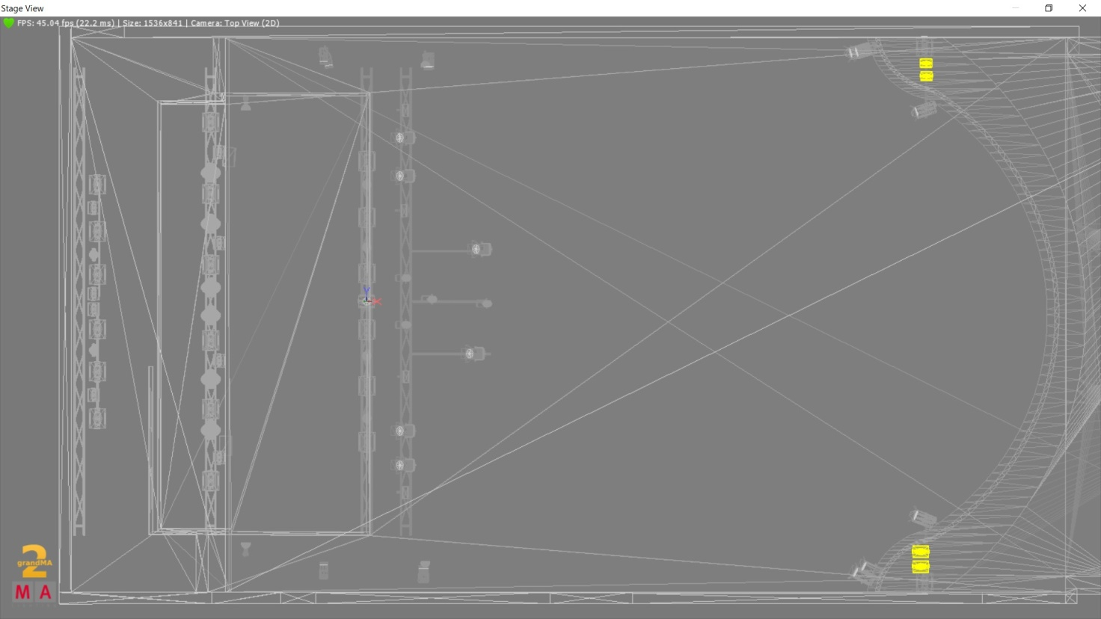

MAC 700
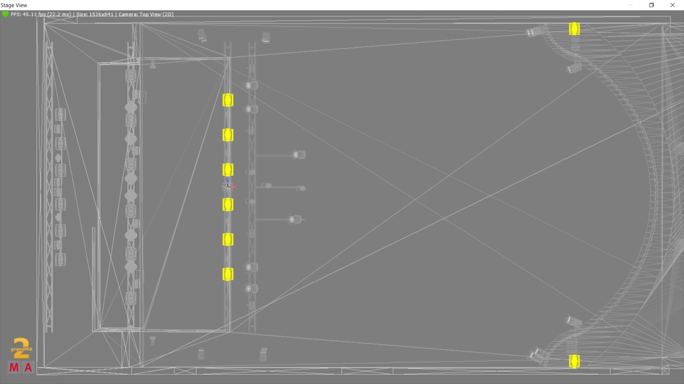

NICK NRG1201

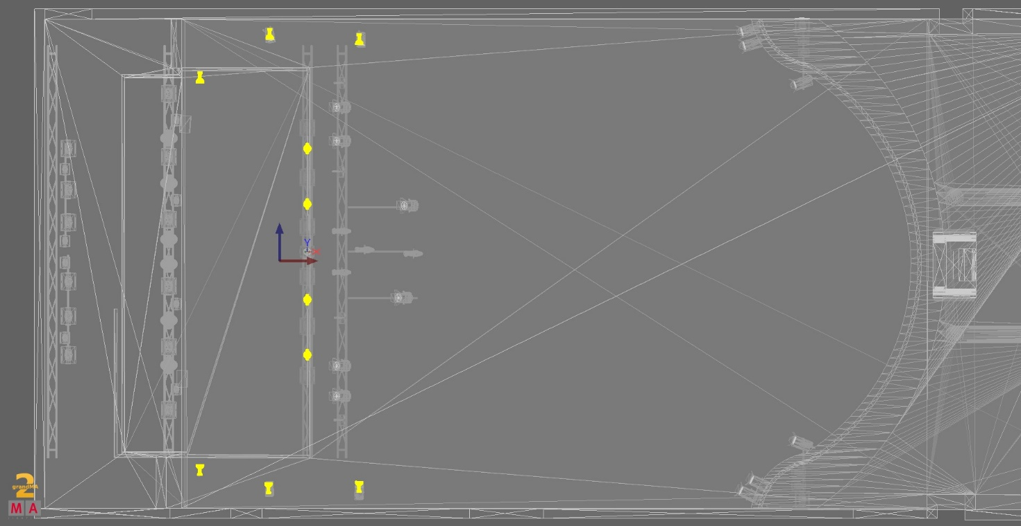

ATOMIC
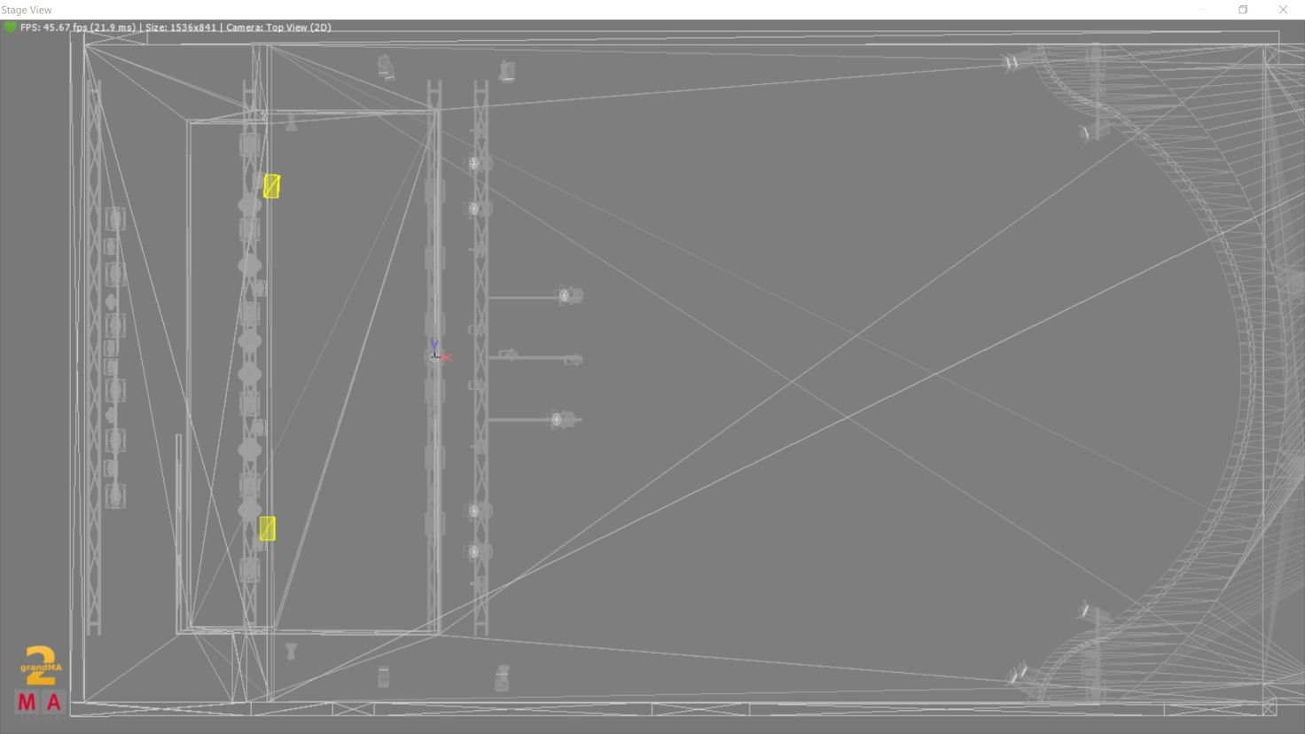

CONVENTIONAL



